Software Design & Architecture

Shipping System
Done by:
Abdelrahman Ahmed
Abdelrahman El Olimy
To:
Dr. Shady Zahran
Date: 4/19/2026

Project Requirements:
- Shipping Vehicle different
- Weight of the item Price and vehicle
- Distance of delivering the item Price and vehicle
- Corriere depending on the vehicle type
- Country type Vehicle type
- Type of item Packaging type
- Date of delivering the order different price
- Review system Customer reviews the Corriere.

We have used a bunch of design patterns while creating this system like: Builder, Singleton, Proxy, Observer, Factory Method, Chain of Responsibility, Decorator, State, Strategy, and Façade.
Builder:
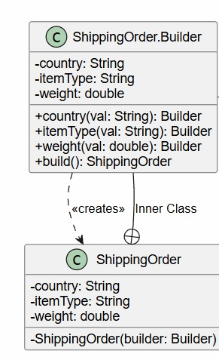
The Builder design pattern is used as an inner class in the ShippingOrder class and it’s called Builder. It’s been chosen to allow the user to set only the fields he care about while still producing a valid object, but there are some required fields that should be exist for an order to be valid (country, itemType, vehicleType). The reason we used Builder is that the ShippingOrder class has about 8 fields which require a huge number of constructers, which is unreadable and error-prone. The builder makes it self-documenting. Also it allows deliverDate to have a default value (“Standard”). It also enforces validation at construction time and produces immutable objects.

Singleton:
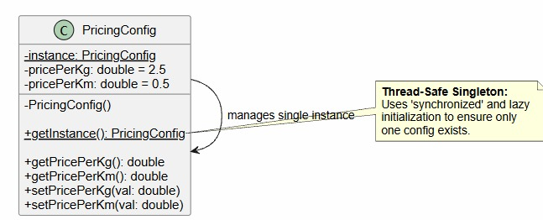
It’s used in the PricingConfig class. It guarantees that only one PricingConfig instance exists in the entire system, so keeping the same value for the weight and distance prices. As in such a complex system where the the prices used in different areas in the code the handlers can create their own different PricingConfig if we make the same variables in each place, but the Singleton prevents that from happening, Also using the synchronized keyword making additional protection against race conditions in multithreaded environments, so only one instance is created in the same time. Singleton also provides a global access point and saves memory.
Proxy:
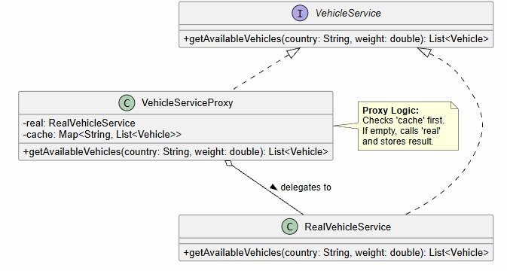
It’s used in the VehicleServiceProxy class. It’s just preventing the user to reach the database each time he make the same query to get a specific output, instead it checks the cache (HashMap) if the result is already stored on it, it returns it immediately without hitting the database.
Observer:
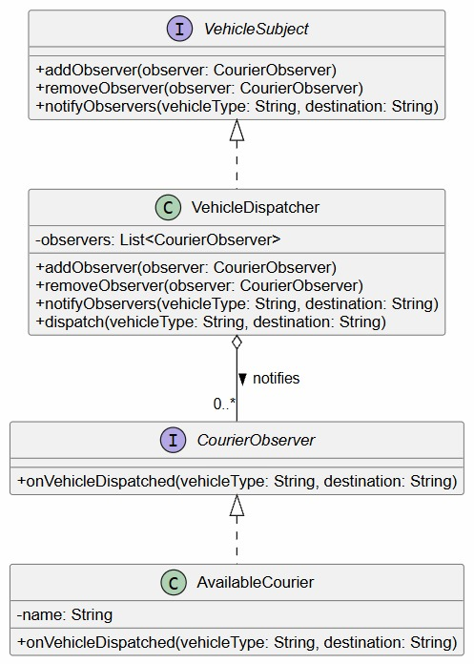
It’s used in the VehicleDispatcher, AvailableCourier, CourierObserver, and VehicleSubject classes. It’s making the couriers get notified automatically if there are any dispatches without constantly checking for dispatches by subscribing via service.registerCourier(). And this happens through the notification from the VehicleDispatcher class to all registered AvailableCouriers. The alternative is to let the ShippingService class keep a list of couriers and call them directly, but it’s tightly couples the dispatch logic to the courier system. While the observer knows nothing about a specific type of observer it’s just notifying.
Factory Method:
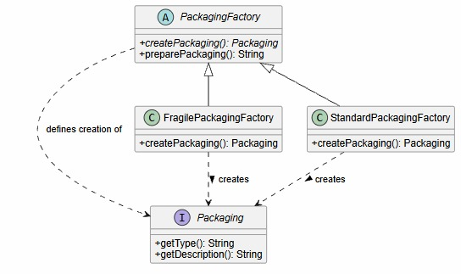
Used in PackagingFactory (abstract), FragilePackagingFactory, and StandardPackagingFactory. It separates object creation from usage, so the code is open for extension but closed for modification. It defines an abstract method createPackaging() that’s being overridden by each concrete subclass to create the appropriate packaging object. The ShippingService class selects which factory to instantiate based on itemType, then calls createPackaging() without knowing what’s inside specifically. It prevents using a lot of if-else statements or a big switch statement that would require modifying ShippingService whenever adding new item type and that violates the OCP.
Chain of Responsibility:
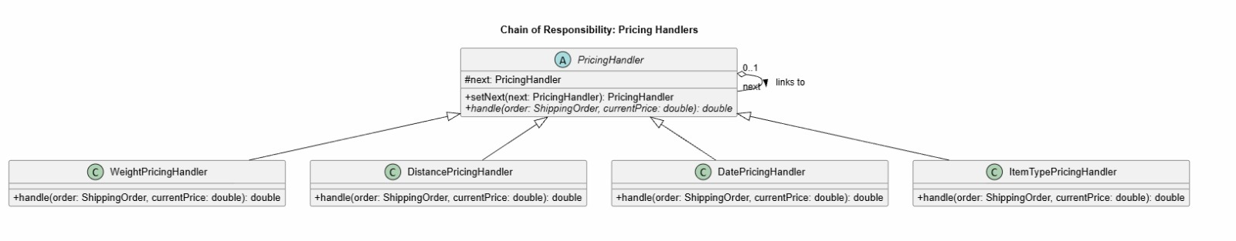
Used in PricingHandler, WeightPricingHandler, DistancePricingHandler, DatePricingHandler, and ItemTypePricingHandler. It makes it easier to add processing steps. Each handler adds its contribution to the price and passes the total price to the next. Each just does its job and doesn’t know about the others. It makes it easier to rearrange or extend the chain without modifying the existing handlers by only making a new class and adding one more .setNext(). Also it’s important as it assures that the price goes through all of the variables that affect it by going through the whole chain.
Weight → Distance → Date → ItemType
- → +37.5 → +150 → ×1.5 → +20 = final price
Decorator:
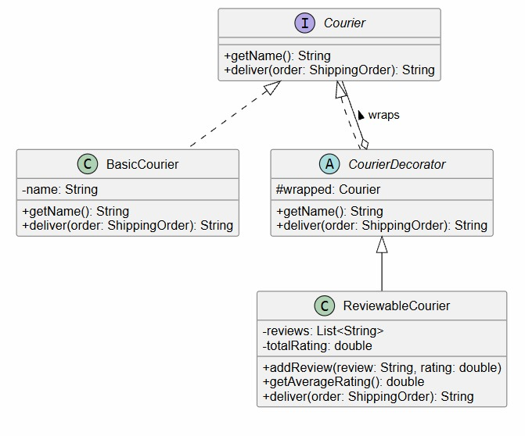
Used in CourierDecorator, ReviewableCourier, and BasicCourier. It adds behavior without modifying the existing classes and supports multiple layers of wrapping and that’s exactly what I needed in the Courier rating system to add more reviews about the courier without the need of modifying the class itself. As ReviewableCourier wraps BasicCourier through the shared Courier interface. It assigns deliver() to the wrapped courier via super.deliver(order), then appends the rating to the result it also adds some methods that doesn’t exist in the BasicCourier class like: addReview() and getAverageRating(). The alternative is the inheritance, but it leads to a class explosion with every combination.
State:
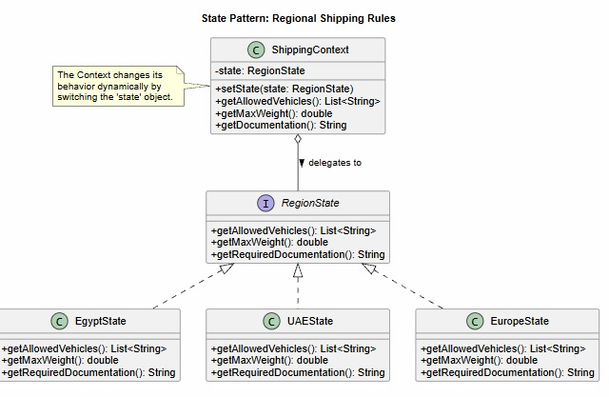
Used in RegionState, EgyptState, UAEState, EuropeState, and ShippingContext. Instead of using a massive if-else statements in the ShippingService class checking the country every time a region-specific behavior needed, State is used to eliminate the complex conditional logic and makes adding new states easy. ShippingContext holds a RegionState object. When context.getAllowedVehicles() called, it delegates to the current state. Also it’s used in switching countries by calling context.setState() which leads to a change in the behavior automatically. So it’s helpful when adding new countries, as we just will make one a new class and one case in resolveState().

Strategy:
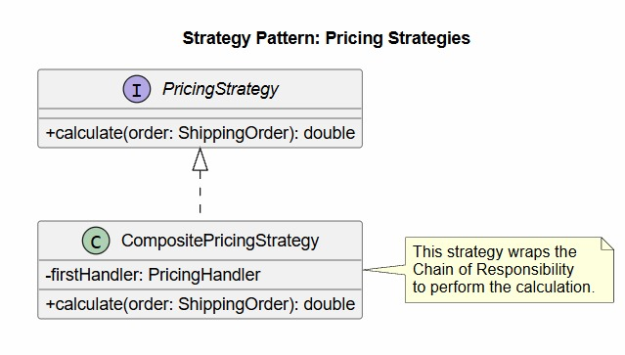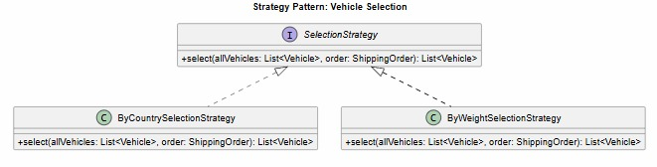
Used in SelectionStrategy, ByCountrySelectionStrategy, and ByWeightSelectionStrategy. It defines a contract for selecting vehicles from a list by making filtration upon the country and the capacity. The strategies can be swapped at runtime to change how the vehicle being selected, as it makes algorithms interchangeable without changing the context and supports runtime algorithm switching. So we can easily add a BySpeedSelectionStrategy or ByPriceSelectionStrategy without changing anything else.
Facade:
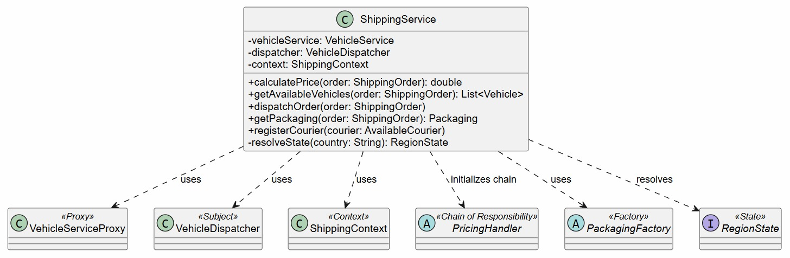
Used in the ShippingService class. It provides a single, clean entry point to the entire system. So instead of Main having to know about all the classes at once, it just talks to ShippingService through simple method calls. We use it as the system has many moving subsystems which makes the program a little complex. And the Façade hides all of that complexity so the caller doesn’t need to know which handler chains exist, which factory to instantiate, or how the observer system works. So Façade is used to reduce coupling between clients and subsystems, make the system easier to use and test, and protect clients from internal restructuring. And that’s exactly what we needed in our system.
UML Diagram:


